Simvastatin Effects on Skeletal Muscle: Relation to Decreased Mitochondrial Function and Glucose Intolerance
S. Larsen, N. Stride, M. Hey-Mogensen, C. N. Hansen, L. E. Bang, H. Bundgaard, L. B. Nielsen, J. W. Helge, and F. Dela.
Center for Healthy Aging and Rigshospitalet, University of Copenhagen, Copenhagen, Denmark.

Background A prevalent side-effect of statin therapy is muscle pain¹, and yet the mechanism behind remain unknown. A statin induced reduction in muscle Q₁₀, may attenuate mitochondrial OXPHOS capacity which may be an underlying mechanism.
Objectives Glucose tolerance and skeletal muscle coenzyme Q₁₀ (Q₁₀) content, mitochondrial density and mitochondrial oxidative phosphorylation (OXPHOS) capacity was measured in ten simvastatin treated patients (45 ± 6 yrs (mean ± SD)) and nine well matched control subjects (45 ± 4 yrs).
Methods Mitochondrial OXPHOS capacity was measured in permeabilized muscle fibers by high-resolution respirometry in a cross-sectional design. Mitochondrial content (estimated by citrate synthase (CS) activity, cardiolipin content, and voltage-dependent anion channel (VDAC) content) as well as Q₁₀ content was determined. Plasma glucose and insulin concentrations were measured during an oral glucose tolerance test.
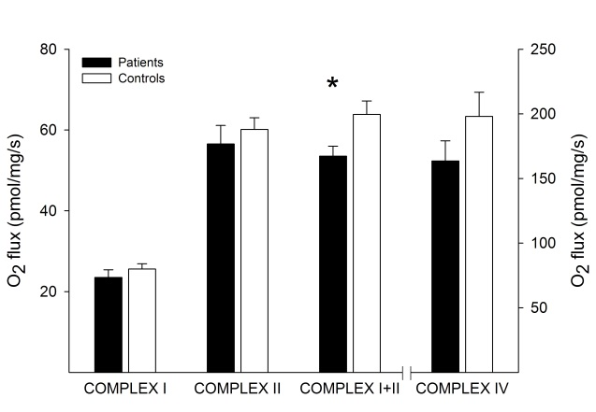
Results Q₁₀ content was reduced by 16% in the patients compared with controls (P=0.05), while mitochondrial content was similar in the patients and the control subjects (CS: 101 ± 18 and 116 ± 25 µmol/min/gram dry weight muscle, respectively). OXPHOS capacity was comparable between groups when complex I and complex II linked substrates were used alone, but when complex I+II linked substrates were used (eliciting convergent electron input into the Q-intersection (maximal ex vivo OXPHOS capacity)) a decreased (P<0.01) capacity was observed in the patients compared with the control subjects (Figure). Simvastatin treated patients had an impaired glucose tolerance and displayed a decreased insulin sensitivity index compared with the control subjects (Cederholm index: 39 ± 19 and 54 ± 11 mg· L²/ (mmol · mU · min), respectively (P<0.05)).
Conclusion A decreased Q₁₀ content was accompanied by a decreased maximal OXPHOS capacity in the glucose intolerant simvastatin treated patients. It is plausible that this finding partly explains the muscle pain and exercise intolerance that many patients experience with their statin treatment.
References ¹Meador BM, Huey KA: Statin-associated myopathy and its exacerbation with exercise. Muscle Nerve 42:469-479, 2010.

